

Web Analytics (CIT3P51)
Assignment 1 (15%)

Submitted by

<<Kenji Leong>> (<<1505447A>>)

<<10/5/17>>

Annex A: Declaration of Work Originality Template

<<Information Technology>>
Web Analytics (CIT3P51)
Assignment 1 (15%)

Submitted by: <<1505447A >> <<Kenji Leong>> <<P02>>

Date: <<10/5/17>>

“By submitting this work, I am declaring that I am the originator of this work and that all other original sources used in this work have been appropriately acknowledged.

I understand that plagiarism is the act of taking and using the whole or any part of another person’s work and presenting it as my own without proper acknowledgement.

I also understand that plagiarism is an academic offence and that disciplinary action will be taken for plagiarism.”

Name and Signature of student: …………………………………...

Table of Contents
Contents
Annex A: Declaration of Work Originality Template 1
Background 3
What might their target demographic be? 3
How would you increase traffic to this website? 4
How could you get that target demographic to visit the site? 5
How would you use the analytical data from different sources to show that you reached the target demographic? 6
What are the ways to promote it online and offline? 8
Appendix B: References 10

Web Analytics (CIT3P51)
Assignment 1 (15%)

Background

New Balance was created by an American company based in Boston and the company started in 1906 where they produce popular footwear for sports athlete such as the 990 model. Besides, New Balance shoe tends to be more expensive than other manufactures because of its technical features such as blended gel inserts, heel counters and also a greater selection of sizes.

What might their target demographic be?

Firstly, their target demographic might be towards young adult between the age of 18 to 35 years old because New Balance consistently produce many shoes with different models for fashion purposes and sports. For example, the 1978 New Balance sneaker was designed for modern styling to allow the user to match it with any outfit that they are wearing and the materials is durable for user to participate in sports activities. Thus, this type of product will appeal to young adult because this is the time period where they would care more about their appearance and also they can wear this shoe for sports activities, which is very convenient for them.
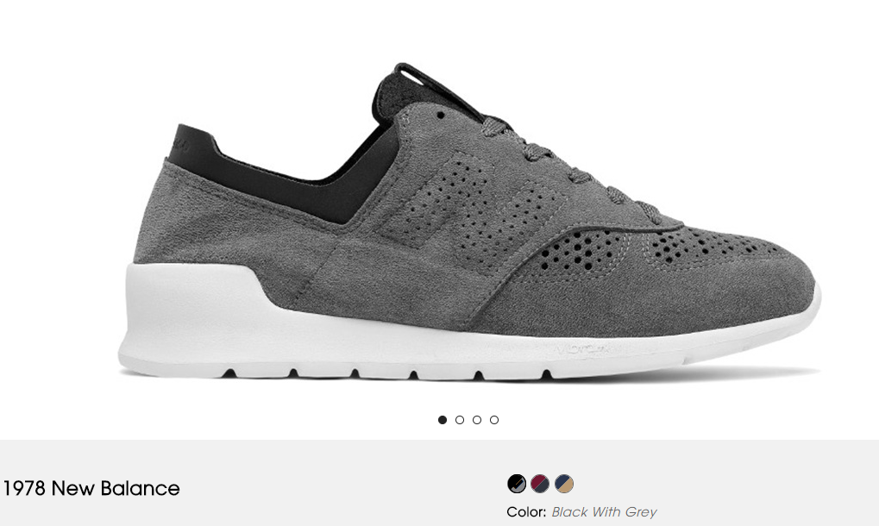
Besides, New Balance also aims towards children under the age of 18 years old as they sell many different types of shoe ranging from running, lifestyle and infant where each of this shoe has their own individual characteristics. For example, as shown below, 247 Classic model are targeted for pre-school students and infants where the shoe is durable and lightweight to meet the tough demand of a children such as running and jumping around all day. Also, the material is stretchable so it is comfortable for children to wear all day.
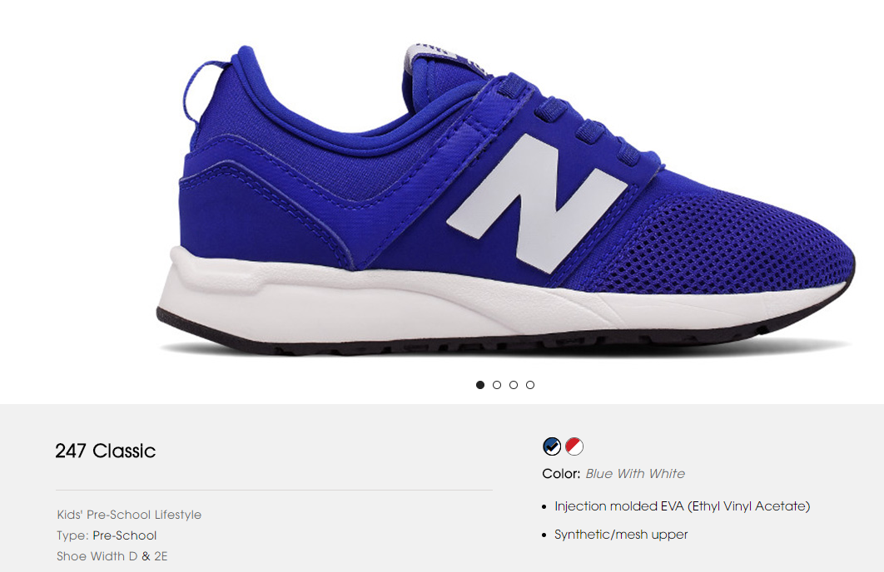

How would you increase traffic to this website?
Firstly, research on what keyword that user use to search for your website through using SEO services such as Similar Web. As shown below, “New Balance” is one of highest searched keyword.

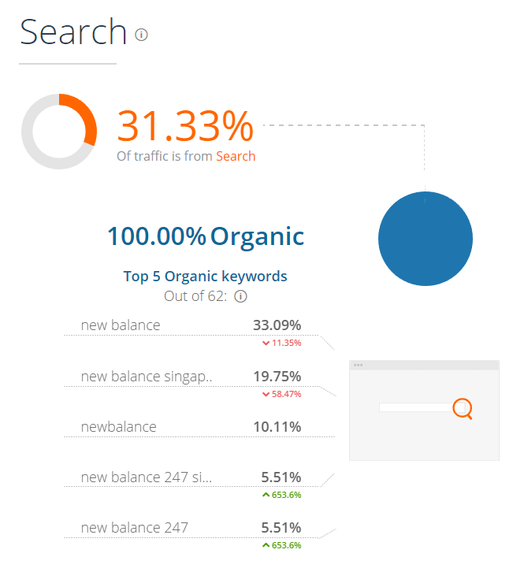
Next, use this word a few time within the page in a way that relates to the rest of the text and is natural. For example, for the description for each shoe you can mention what features New Balance has implemented and add it in the title tag. However, you should not keep on reusing this word on pages that are irrelevant as going over the top will get you punished in the SEO rankings.

Besides, you should also use keywords that are unique but still relevant to your business because this can help to reduce competition when searching for you websites. For example, if New Balances uses keywords such as “Sports shoes”, where there are more popular shoes company that uses this such as Adidas or Nike. As a result, the chances of New Balance showing up on the first page of the search result is much slimmer.

Also, you have to ensure the unique keywords has also some searches before setting them because if the keyword is too unique it is hard for users to be able to search for your website. As a result, the keyword should include a purpose that links to what the user wants. For example, “Buy New Balance running shoes”.

Lastly, having quality content for your websites is very important in terms of user interface and originality because with a good user interface it can provide good navigation for the user and can also reduce the bounce rate. As shown below, on the homepage for New Balance, they only show the latest model of their shoes.

New Balance
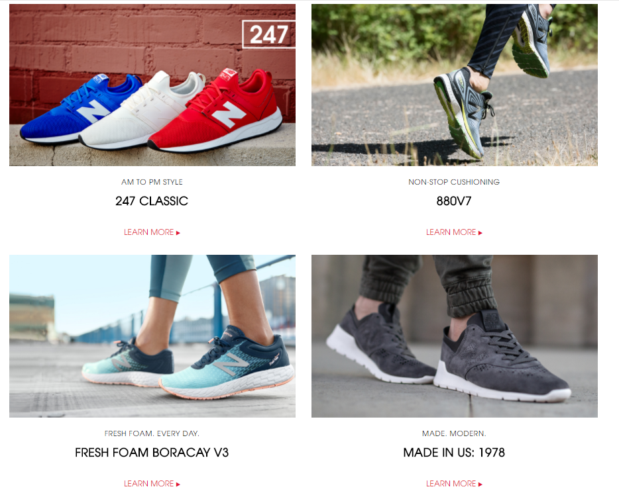
Adidas
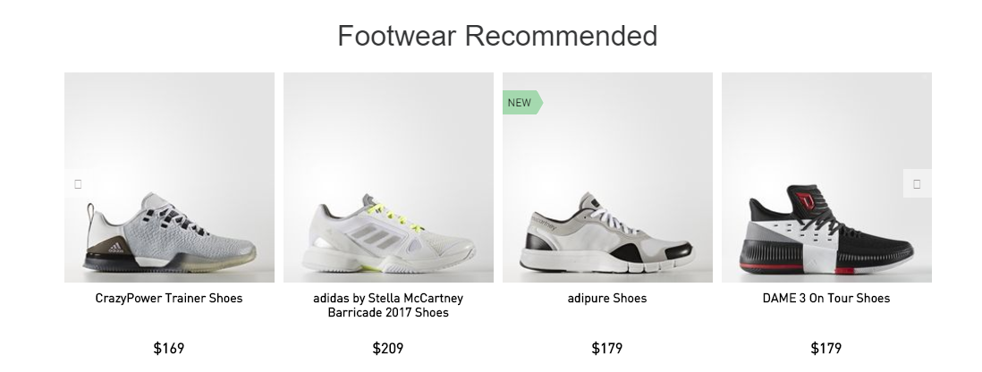

On the other hand, for Adidas other than showing the latest model they also show what are the recommended shoes that user should buy. As a result, when new user enters the website for New Balance they would not know what types of shoes they should buy because there are too many different models to choose from. However, for Adidas they would spend more time because user will definitely click on the shoes that are more popular first.

Thus, in order to increase the traffic for New Balance, it is important for them to ensure that they would need to research on what keywords user use to search for their website. After that, choose a unique keywords that is relevant to their business but is not too unique as this can make it hard for other users to search for the website on Google. Lastly, make sure that your website provides quality content in terms of user interface and originality to provide better navigation. Also, it should not be misleading when the user clicks on your website as this can lead to high bounce rate.

How could you get that target demographic to visit the site?

Firstly, in order to attract young adults to visit the site. New Balance can make use of social media such as Twitter or website such as Google Trend to identify which type of shoe is trending currently. For example, as shown below, Yeezy which is from Adidas is currently one of the most popular sneaker on the market since it is the first result that appear when you type “shoe” onto the search engine on Twitter.

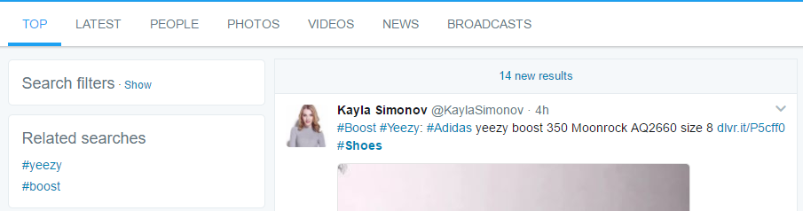

As a result, New Balance can learn from Adidas such as what type of design, material or features that makes the sneaker appeals to young adult. Thus, New Balance can create a sneaker that is unique but still incorporating some the features and design that New Balance already has developed.
Besides, in order to attract children to visit the site. New Balance can collarborate with school or day care centre as they can help to generate backlinks. For example, when children visit the school website, if they want to buy a pair of shoe, under the apparel section a hyperlink such as click “here” can be generated where after clicking it will link to the children section in the New Balance website. Also, the design shoe can include striking colours such as red, blue or green so that they can identify and make the shoe more appealing.

How would you use the analytical data from different sources to show that you reached the target demographic?

Firstly, Google Analytic is a software analytic tool that can be used to measure the traffic visiting your website in terms of demographic. As shown below, by clicking on the demographic features, there will be a list of sub tasks such as overview, age and interest that the admin can see to track whether New Balance has reached the target demographic.

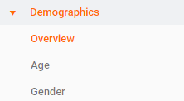

Besides, as shown below when the admin clicks on overview, there will be three section shown such as converter, iOS and android traffic. By doing so, the admin will be able to see a bar charts from different platforms as it shows which age range has the highest visit and the percentage of each age range. Also, at the bottom a pie chart represents the gender in terms of percentage and this can determine which type of gender visit the New Balance most. As a result, by analysing this data, New Balance will be able to know whether they have reached the target audience as they should take up most of the percentage.

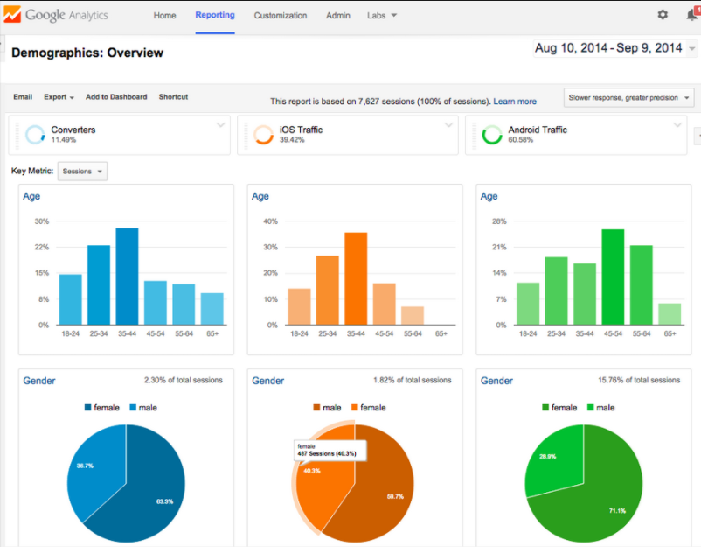

Lastly, Yahoo Analytic software is also another alternative that can also be used to analyse the demographic. As shown below, in the overview dashboard, similarly to google analytic it also has uses a bar chart to represent age. However, for gender it uses a bar instead of a pie chart and there are two more charts such as the top countries and languages when visiting the website. Besides, at the top, yahoo analytic allow you to choose which platforms you want to compare with such as comparing between Android and IOS.

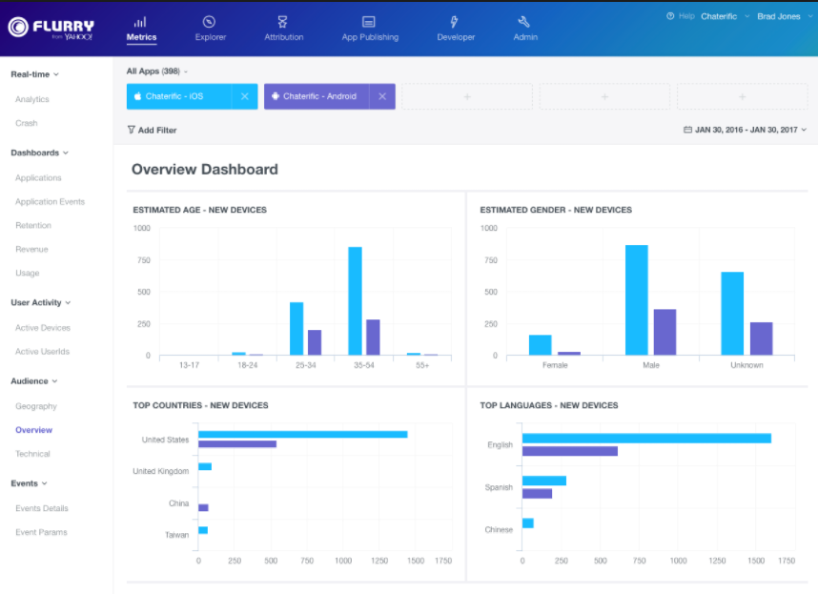
Thus, both Google and Yahoo analytic tools can help New Balance to determine whether they have reached their target demographics from multiple platforms such as mobile to website. Besides, other than showing the age, it also allows them to track the gender, countries, languages and number of converters, which this are useful information for further analysis of New Balance.

What are the ways to promote it online and offline?
Firstly, in order to promote online, New Balance can make use of Search Engine Marketing (SEM) such as paid advertising on the search result. The difference between SEO and SEM is that SEO is to help the website to achieve a better search ranking. On the other hand, SEM makes use of methods such as paid advertising to show the website first on the search result. For example, as shown below, when a user search such as “seo audit service”, the advertisement of the website will always be shown first at the search result, followed by the actual links.
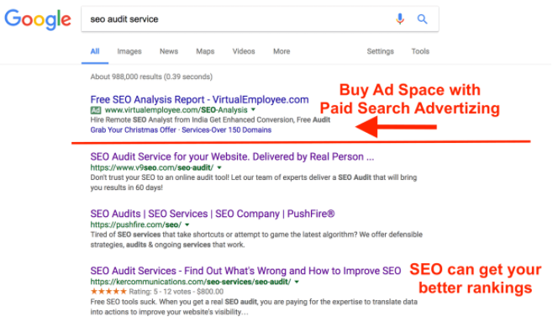

As a result, SEM can help New Balance to promote their website because majority of the user will only look at the golden triangle, which are the first three links shown on the first page of the search result and since the advertisement are always shown first. Thus, user will definitely be able to see the New Balance website.

Besides another way to promote online is to make use of social media since this is an emerging technology that is getting more and more popular towards the younger generation, which is what New Balance is targeting at. For example, as shown below, Adidas collaborate with celebrity such as Messi which is a renounce soccer players that has a huge fan base throughout the world.



As a result, New Balance can also promote online through collaborating with celebrity and bloggers as they can help promote the shoes through their personal influence and they can also help generate backlinks to the New Balance by promoting the shoes on their social media.

On the other hand, in order to promote offline, New Balance can promote their shoe on magazine that is popular among the younger generation reads such as Teenage. As a shown below, the reason why Teenage is popular is because they hire celebrity from different countries to market their magazine.



Besides, New Balance can also post advertisement on newspapers such as The Straits Time. Newspapers is popular because it is still one of the most conventional method to read news since not everyone has the time to watch television and it has also attracted audience from different ages.

As a result, by posting advertisement on magazine and newspaper, it can definitely help to promote New Balance to the younger generation, which is what their target demographics is. Besides, newspapers can help to attract even more audiences from different age range.

Appendix B: References
10 Advanced SEO Techniques that’ll Double Your Search Traffic. (n.d.). Retrieved from http://neilpatel.com/blog/10-advanced-seo-techniques-thatll-double-your-search-traffic/
4 Ways to Improve Search Engine Optimization - wikiHow. (n.d.). Retrieved May 10, 2017, from http://www.wikihow.com/Improve-Search-Engine-Optimization
About Demographics and Interests - Analytics Help. (n.d.). Retrieved from https://support.google.com/analytics/answer/2799357?hl=en
adidas Official Website | adidas. (n.d.). Retrieved from http://www.adidas.com.sg/
Demographics - Yahoo Developer Network. (n.d.). Retrieved from https://developer.yahoo.com/flurry/docs/analytics/lexicon/demographics/
Google Trends. (n.d.). Retrieved from https://trends.google.com.sg/trends/
New Balance Singapore. (n.d.). Retrieved from http://www.newbalance.com.sg
Pardon Our Interruption. (n.d.). Retrieved from
https://www.similarweb.com/website/newbalance.com.sg

